www.astekglobe.com
ATA050 SERIES 50W DOE VI Adapter
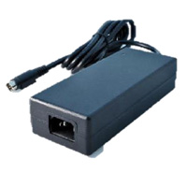
Features
*Universal AC Input Range
*Protections: Short Circuit/Overload/ Overvoltage
*Efficiency: Level VI and V (optional)
*DOE VI/ErP/ UL/cUL/TUV-GS/CB/BSMI/PSE/ CE/VCCI/LVD approved.
*1 year warranty
Input
Voltage: 90~264VAC
Frequency: 50~60Hz
Input current: 1.2ARMS @115VAC
Efficiency Level VI
Output
Part No Rated O/P Ripple & Noise(mVp-p)
ATA050-S12-z 12V/4.17A 240
ATA050-S15-z 15V/3.34A 240
ATA050-S19-z 19V/2.64A 240
ATA050-S24-z 24V/2.09A 240
ATA050-S48-z 48V/1.05A 480
ATA050-S56-z 56V/0.9A 560
z: 14=C14, 08=C8
Mechanical Drawing C14/C8 inlet, Size: 117.6*50.2*31.6mm
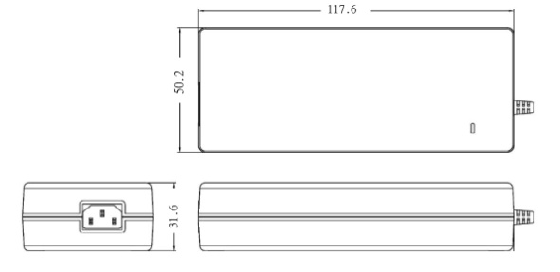
Load Regulation: +/-5% Max.
Line Regulation: +/- 1% Max.
Over Load Protection/Short Circuit Protection: Hiccup/Auto Recovery
Over Voltage Protection: Latch Off
Operating Temperature: 0~40degree C
Storage Temperature: -40~85degree C
Storage Humidity: 5~95% RH
Safety approvals: DOE VI, UL, cUL,TUV-GS, CB, BSMI,PSE
EMC: CE, VCCI, LVD

