www.astekglobe.com
ATA036 SERIES 36W DOE VI Adapter
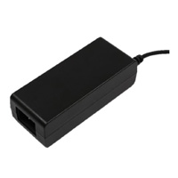
Features
*Universal AC Input Range
*Protections: Short Circuit/Overload/ Overvoltage
*Efficiency: Level VI and V (optional)
*DOE VI/ErP/ UL/cUL/TUV-GS/CB/BSMI/CE/VCCI/LVD approved.
*1 year warranty
Input
Voltage: 90~264VAC
Frequency: 50~60Hz
Input current: 0.75ARMS @115VAC, 0.56ARMS @230VAC
Efficiency Level VI
Output
Part No Rated O/P Ripple & Noise(mVp-p)
ATA036-S12-z 12V/3A 150
ATA036-S24-z 24V/1.5A 150
ATA036-S48-z 48V/0.75A 240
ATA036-S56-z 56V/0.64A 240
z: 14=C14, 06=C6, 08=C8
Mechanical Drawing C14/C6/C8 inlet, Size: 110.2*46.2*31.6mm
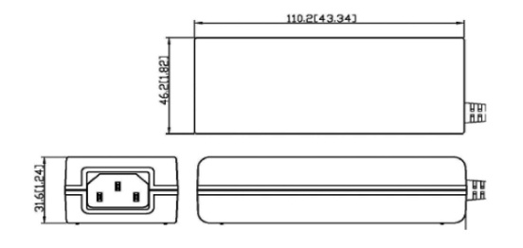
Load Regulation: +/-5% Max.
Line Regulation: +/- 0.5% Max.
Over Load Protection/Short Circuit Protection: Hiccup/Auto Recovery
Over Voltage Protection: Latch Off
Operating Temperature: 0~40degree C
Storage Temperature: -40~85degree C
Storage Humidity: 5~95% RH
Safety approvals: DOE VI, UL, cUL,TUV-GS, CB, BSMI
EMC: CE, VCCI, LVD

