www.astekglobe.com
APA050 SERIES 50W DOE VI Adapter
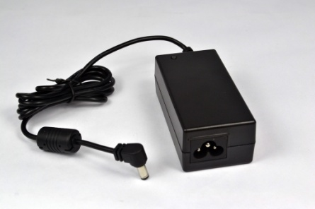
Features
*Universal AC Input Range
*Protections: Short Circuit/Overload/ Overvoltage
*Efficiency: Level VI and V (optional)
*DOE VI/ErP
*Pass LPS/LVD
*100% Hi-Pot & ATE Chroma test
*100% Burn-in test High Ambient Temp(45°C)
Input
Voltage: 90~264VAC
Frequency: 50~60Hz
Input current: 1.8A max.
Inrush current: 80A max
Efficiency Level VI and V (optional)
Output
Part No O/P Voltage O/P Current(max.) watt Max
APA050-S12-z 9~14.9V 5.55A 50W
APA050-S24-z 15~24V 3.33A 50W
APA050-S36-z 24.1~36V 2.07A 50W
APA050-S48-z 36.1~48V 1.38A 50W
z: U=US, E=EU, A=Australia/New Zealand, B=British, K=Korean, I=Interchangeable, 14=C14, 06=C6, 08=C8
General Specification
Load Regulation: 5% Max.
Line Regulation: 1% Max.
Over Voltage Protection/Short Circuit Protection: Auto Recovery
Ripple & Noise: 1%
Operating Temperature: 0~40degree C
Storage Temperature: -20~85degree C
Storage Humidity: 5~95% RH
Mechanical Type: Interchangeable US/EU/UK/AU/China adapter, Desktop C8/C6/C14 inlet
Safety approvals: DOE VI, UL,cUL, TUV-GS, CB,CE, FCC
EMC: CE, VCCI, LVD,FCC

Mechanical Drawing

Interchangeable plug Desktop C14
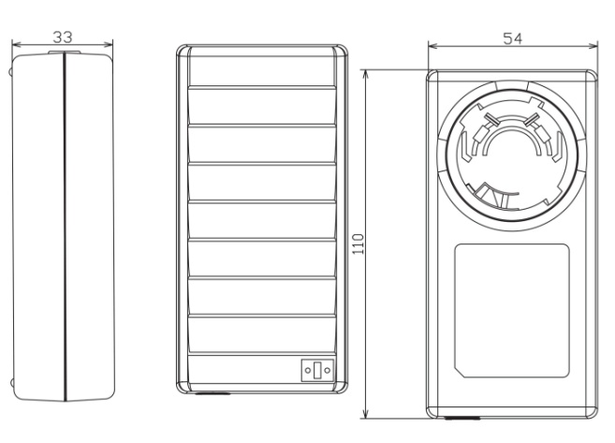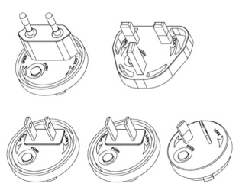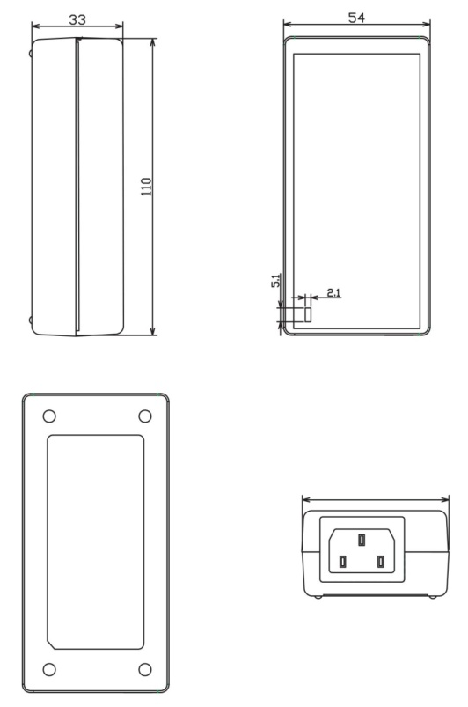
Desktop C8 Desktop C6
