www.astekglobe.com
APA045 SERIES 45W DOE VI Adapter
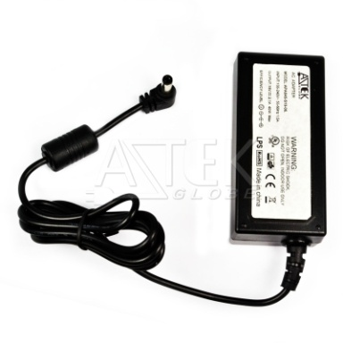
Features
*Universal AC Input Range
*Protections: Short Circuit/Overload/ Overvoltage
*Efficiency: Level VI and V (optional)
*DOE VI/ErP
*Pass LPS/LVD
*100% Hi-Pot & ATE Chroma test
*100% Burn-in test High Ambient Temp(45°C)
Input
Voltage: 90~264VAC
Frequency: 50~60Hz
Input current: 1.0~1.5A max.
Inrush current: 80A max
Efficiency Level VI and V (optional)
Output
Part No O/P Voltage O/P Current(max.) watt Max
APA045-S12-z 12~18.9V 3.33A 40W
APA045-S24-z 19~24V 2.1A 40W
APA045-S36-z 24.1~36V 1.66A 40W
APA045-S48-z 36.1~48V 1.0A 40W
z: U=US, E=EU, A=Australia/New Zealand, B=British, K=Korean, I=Interchangeable, 14=C14, 06=C6, 08=C8
General Specification
Load Regulation: 5% Max.
Line Regulation: 1% Max.
Operating Temperature: 0~40degree C
Storage Temperature: -20~85degree C
Storage Humidity: 5~95% RH
Over Voltage Protection/Short Circuit Protection: Auto Recovery
Ripple & Noise: 1%
Mechanical Type: Interchangeable US/EU/UK/AU/China adapter, Fixed Plug US 2pin/3pin plug, EU/AS
2pin/3pin Plug, Desktop C8/C6/C14 inlet,
Safety approvals: DOE VI, UL,cUL, TUV-GS, CB,CE, FCC
EMC: CE, VCCI, LVD,FCC
Mechanical drawing
Interchangeable plug US 3pin plug US 2pin plug UK 3pin plug
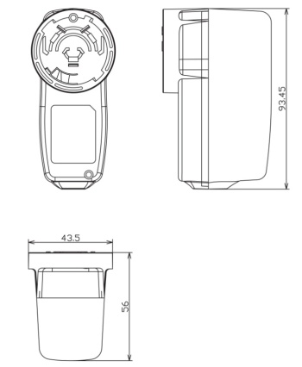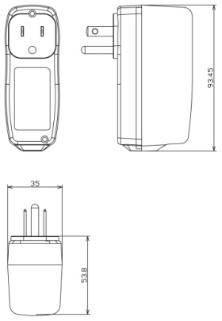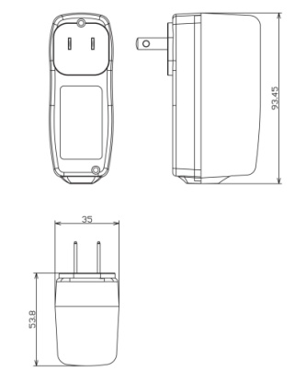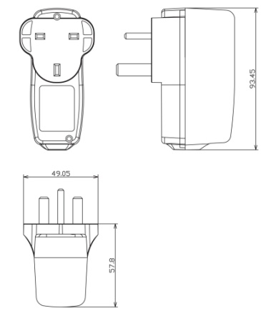
AU 3pin plug AU 2pin plug EU Plug
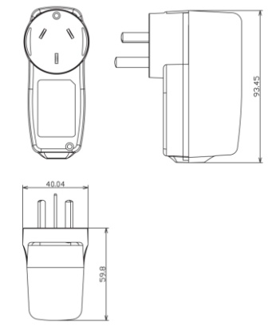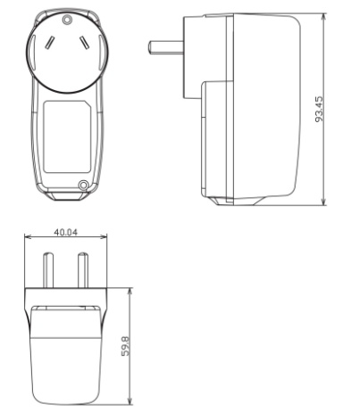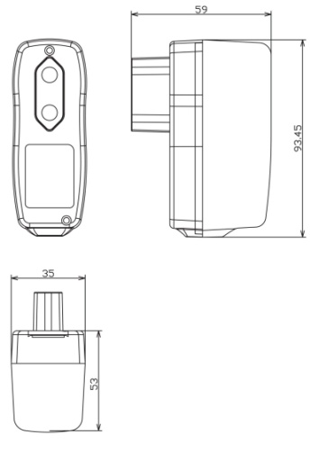
C14 inlet C8 inlet C6 inlet
