www.astekglobe.com
APA030 SERIES 16/24/30W DOE VI Adapter
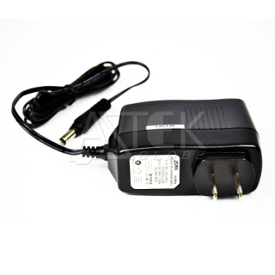
Features
*Universal AC Input Range
*Protections: Short Circuit/Overload/ Overvoltage
*Efficiency: Level VI and V (optional)
*DOE VI/ErP
*Pass LPS/LVD
*100% Hi-Pot & ATE Chroma test
*100% Burn-in test High Ambient Temp(45°C)
*Application: IT/Travel Charger, Communication, Battery charger(CC mode) etc.
Input
Voltage: 90~264VAC
Frequency: 50~60Hz
Input current: 0.8A max.
Inrush current: 60A max
Efficiency Level VI and V (optional)
Output
Part No O/P Voltage O/P Current(max.) watt Max
APA030-S03-z 3~3.9V 4A 16W
APA030-S05-z 4~6V 4A 24W
APA030-S07-z 6.1~7.4V 3.5A 30W
APA030-S09-z 7.5~9.9V 3.5A 30W
APA030-S12-z 10~14.9V 3A 30W
APA030-S18-z 15~19.9V 2A 30W
APA030-S24-z 20~29.9V 1.5A 30W
APA030-S36-z 30~39.9V 1A 30W
APA030-S48-z 40~50V 0.75A 30W
z: U=US, E=EU, A=Australia/New Zealand, B=British, K=Korean, I=Interchangeable
Load Regulation: 5% Max.
Line Regulation: 1% Max.
Operating Temperature: 0~40degree C
Storage Temperature: -20~85degree C
Storage Humidity: 5~95% RH
Over Voltage Protection/Short Circuit Protection: Auto Recovery
Ripple & Noise: 1%
Mechanical Type: Fixed and Interchangeable US/EU/UK/AU/China adapter, Desktop C8/C6/C14 inlet
Safety approvals: DOE VI, cTUVus, TUV-GS, CB,CE, FCC, BSMI
EMC: CE, VCCI, LVD,FCC
Mechanical Drawing
Interchangeable plug Australian 2pins plug Australian 3pins plug
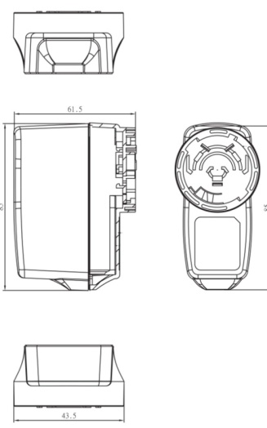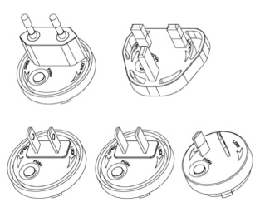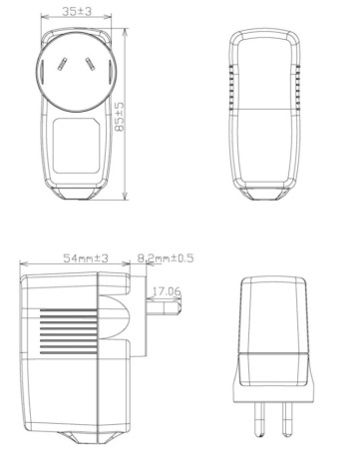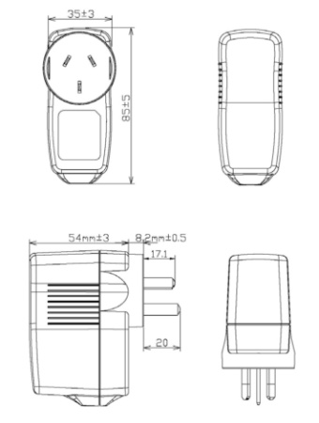
UK plugs UK 3pins plug EU plug China plug
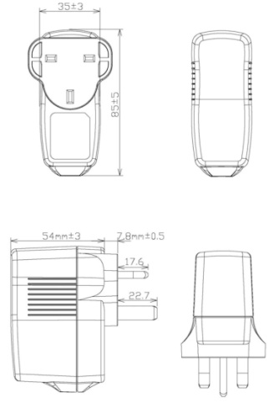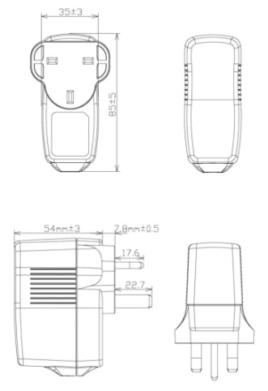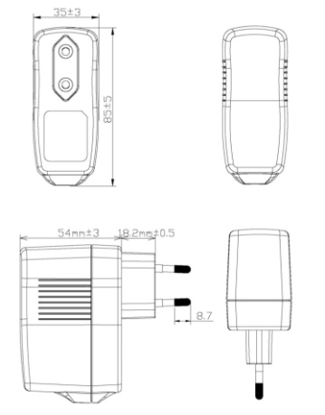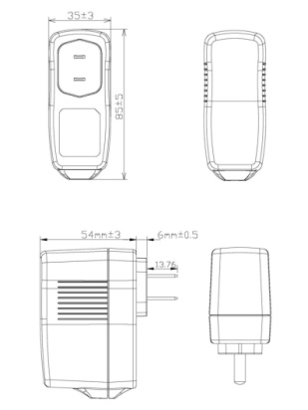
US 2pins plug US 3pins plug Korean plug
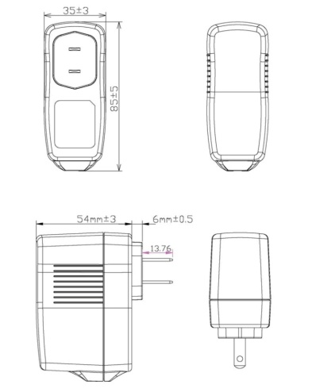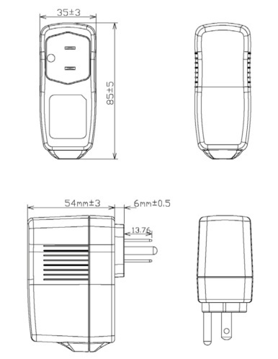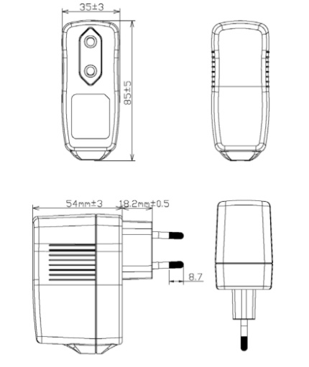

Desktop adapter
