www.astekglobe.com
APA024 SERIES 15/20/24W DOE VI Adapter
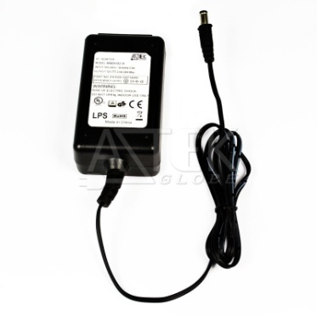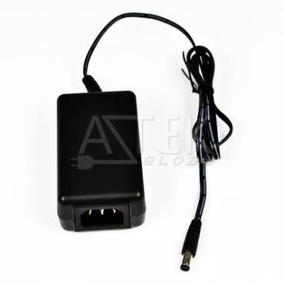
Features
*Universal AC Input Range
*Protections: Short Circuit/Overload/ Overvoltage
*USB socket provided.
*Efficiency: Level VI and V (optional)
*DOE VI/ErP
*Pass LPS/LVD
*100% Hi-Pot & ATE Chroma test, 100% Burn-in test High Ambient Temp(45°C)
*Application: IT/Travel Charger, Communication, Battery charger(CV mode) etc.
Input
Voltage: 90~264VAC
Frequency: 50~60Hz
Input current: 0.3A max.
Inrush current: 40A max
Efficiency Level VI and V (optional)
Output
Part No O/P Voltage O/P Current(max.) watt Max
APA024-S03-z 3~4.5V 3A 15W
APA024-S07-z 4.9~7.000V 3A 20W
APA024-S09-z 7.1~10.5V 2.85A 24W
APA024-S15-z 10.6~15V 2A 24W
APA024-S18-z 15.1~21V 1.6A 24W
APA024-S24-z 21.1~30V 1.14A 24W
APA024-S36-z 30.1~40V 0.8A 24W
APA024-S48-z 40.1~50V 0.6A 24W
z: U=US, E=EU, A=Australia/New Zealand, B=British, K=Korean, I=Interchangeable, 14=C14, 06=C6, 08=C8
Load Regulation: 5% Max.
Line Regulation: 1% Max.
Operating Temperature: 0~40degree C
Storage Temperature: -20~85degree C
Storage Humidity: 5~95% RH
Mechanical Type: Fixed and Interchangeable US/EU/UK/AU/China adapter, Desktop C8/C6/C14 inlet
Safety approvals: DOE VI, cTUVus, TUV-GS, CB,CE, FCC, PSE, BSMI, NOM
EMC: CE, VCCI, LVD,FCC
Over Voltage Protection/Short Circuit Protection: Auto Recovery
Ripple & Noise: 1%
Mechanical Drawing
Interchangeable plug AS 2pins plug AS 3pins plug
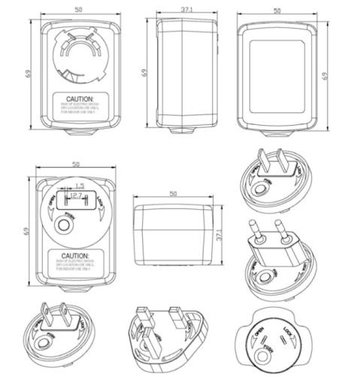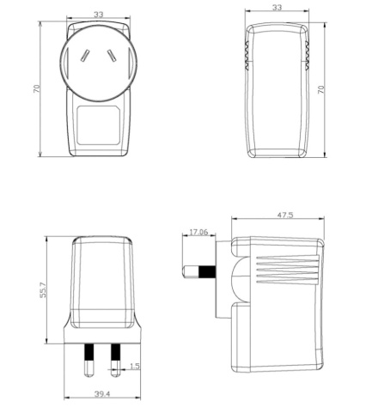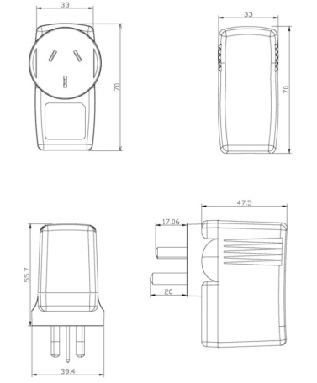
UK plug EU plug US 2pin plug
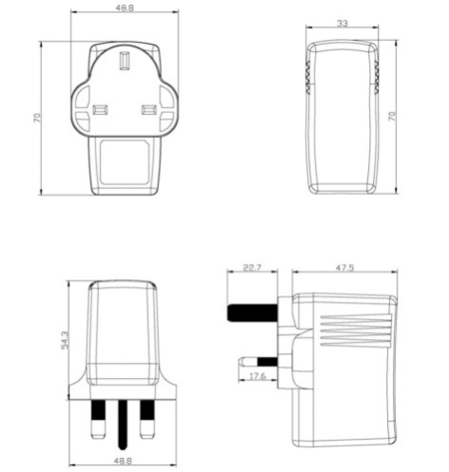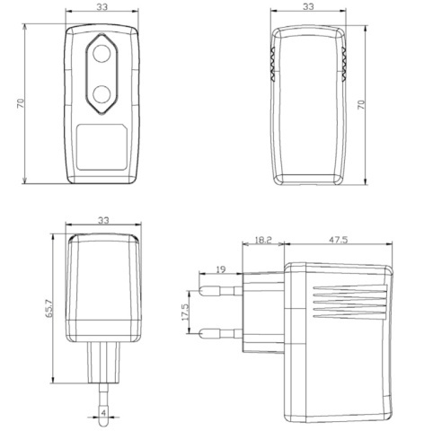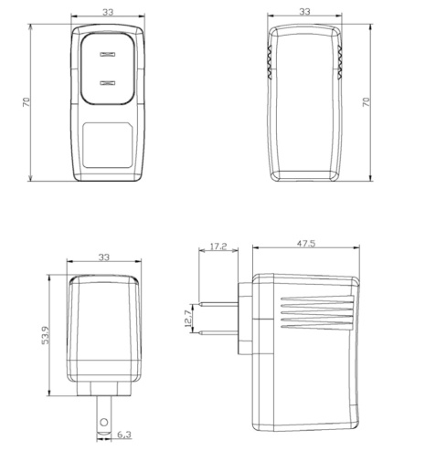
US 3pins plug China 2pins China 3pins
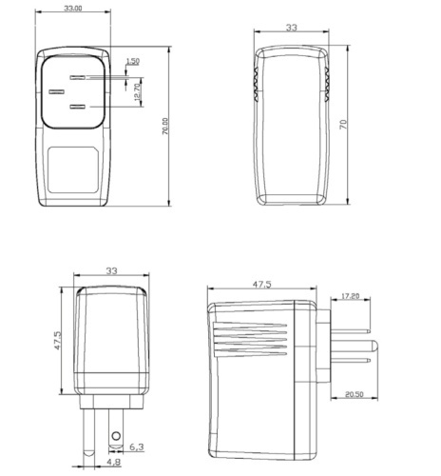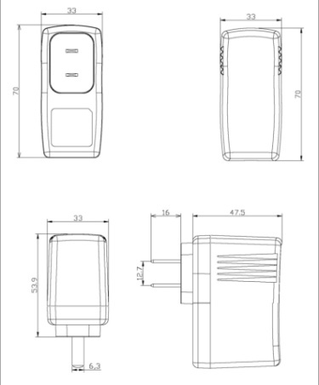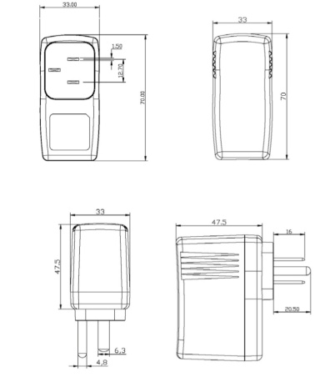

Korean plug Desktop size
