www.astekglobe.com
APA015 SERIES 15-18W DOE VI Adapter
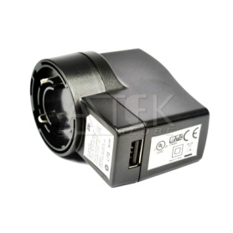
Features
*Universal AC Input Range
*Protections: Short Circuit/Overload/ Overvoltage
*USB socket provided.
*Efficiency: Level VI and V (optional)
*DOE VI/ErP
*Pass LPS/LVD
*100% Hi-Pot & ATE Chroma test, 100% Burn-in test High Ambient Temp(45°C)
*Application: IT/Travel Charger, Communication, Battery charger(CV mode) etc.
Input
Voltage: 90~264VAC
Frequency: 50~60Hz
Input current: 0.4A max.
Inrush current: 40A max
Efficiency Level VI and V (optional)
Output
Part No O/P Voltage O/P Current(max.) watt Max
APA015-S03-z 3~4.5V 2.6A 15W
APA015-S05-z 4.6~6.9V 2.6A 15W
APA015-S07-z 7.0~10V 2.15A 18W
APA015-S12-z 10.1~14.9V 1.48A 18W
APA015-S15-z 15~21V 1.0A 18W
APA015-S24-z 21.1~30V 0.72A 18W
z: U=US, E=EU, A=Australia/New Zealand, B=British, K=Korean, I=Interchangeable, 14=C14, 06=C6, 08=C8
Load Regulation: 5% Max.
Line Regulation: 1% Max.
Operating Temperature: 0~40degree C
Storage Temperature: -20~85degree C
Storage Humidity: 5~95% RH
Mechanical Type: Fixed and Interchangeable US/EU/UK/AU/China adapter, Desktop C8/C6/C14 inlet
Safety approvals: DOE VI, cTUVus, TUV-GS, CB,CE, FCC, PSE, BSMI, NOM
EMC: CE, VCCI, LVD,FCC
Over Voltage Protection/Short Circuit Protection: Auto Recovery
Ripple & Noise: 1%
Mechanical Drawing
Interchangeable plug Australia plug Australia plug 3pins
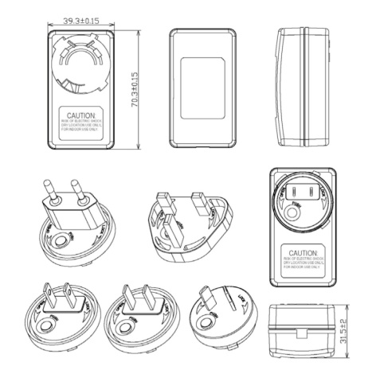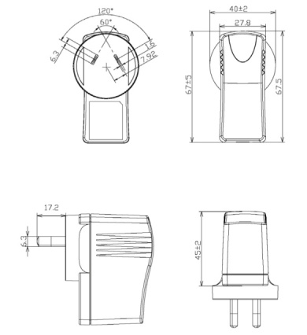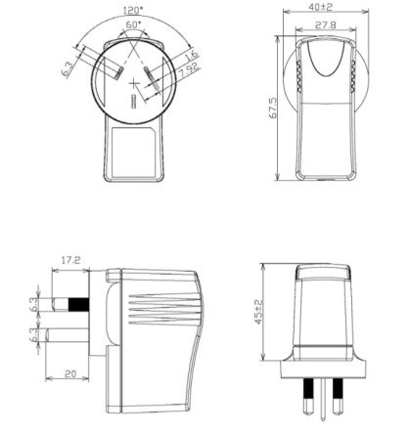
UK plug UK plug 3pins China Plug
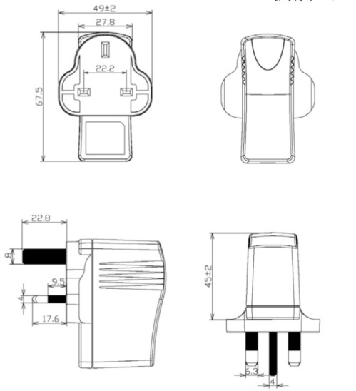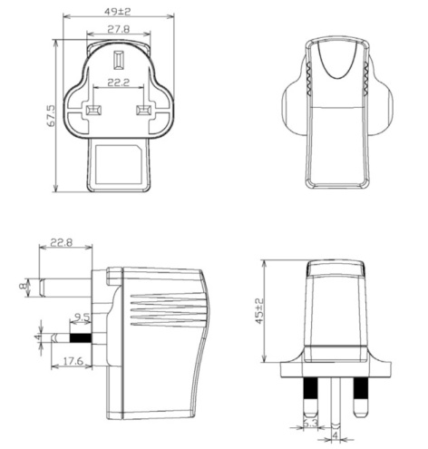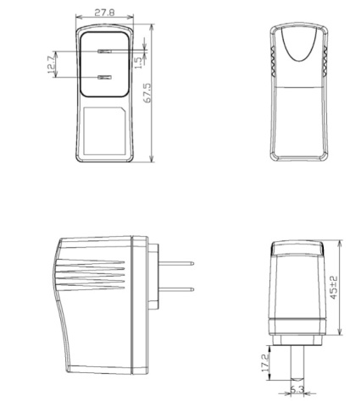
European Plug US plug Korean Plug
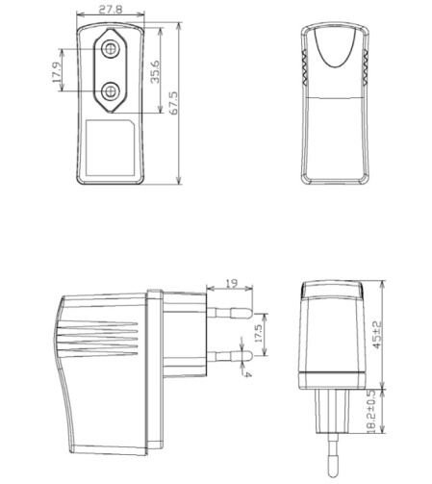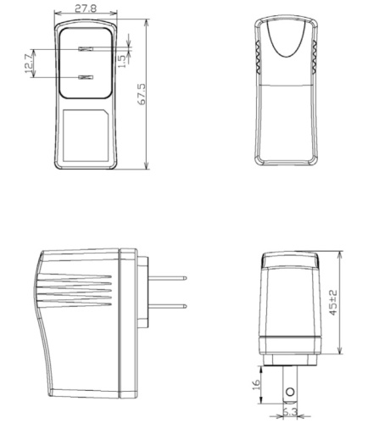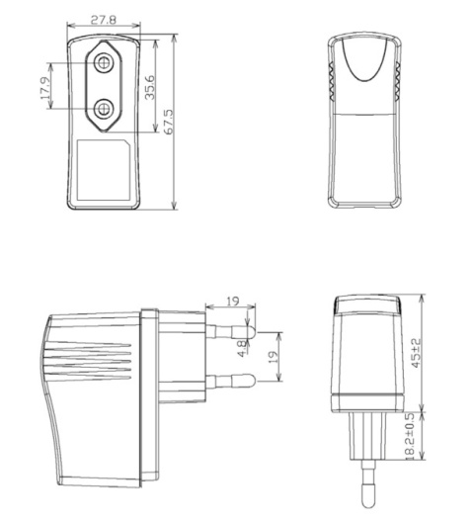
C8 inlet
