www.astekglobe.com
APA005 SERIES 6W DOE VI Adapter
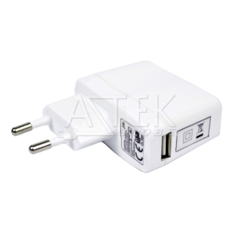
Features
*Universal AC Input Range
*Protections: Short Circuit/Overload/ Overvoltage
*USB Socket provided.
*Efficiency: Level VI and V (optional)
*DOE VI/ErP
*Pass LPS/LVD
*100% Hi-Pot & ATE Chroma test
*100% Burn-in test High Ambient Temp(45°C)
*Application: IT/Travel Charger, Communication, Battery charger(CV mode) etc.
Input
Voltage: 90~264VAC
Frequency: 50~60Hz
Input current: 0.2A max.
Inrush current: 40A max
Efficiency Level VI and V (optional)
Output
Over Voltage Protection/Short Circuit Protection: Auto Recovery
Ripple & Noise: 2%
Part No O/P Voltage O/P Current(max.) watt Max
APA005-S03-z 3~4.9V 1.5A 5W
APA005-S05-z 5~7.4V 1A 5W
APA005-S7.5-z 7.5~12V 0.67A 5W
APA005-S12-z 12~15V 0.5A 6W
z: U=US, E=EU, A=Australia/New Zealand, B=British, K=Korean, I=Interchangeable
Load Regulation: 5% Max.
Line Regulation: 1% Max.
Operating Temperature: 0~40degree C
Storage Temperature: -20~85degree C
Storage Humidity: 5~95% RH
Mechanical Type: Fixed and Interchangeable US/EU/UK/AU/KR plug, USB also provide
Safety approvals: DOE VI, UL,cUL,TUV-GS, CB,CE, FCC,VCCI, NRCAN, KC, PSB,BSMI
EMC: CE, VCCI, LVD,FCC
Mechanical Drawing
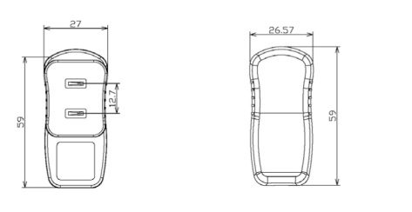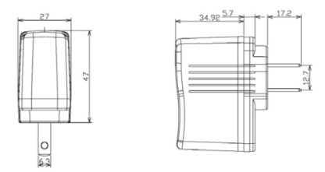US fixed adapter
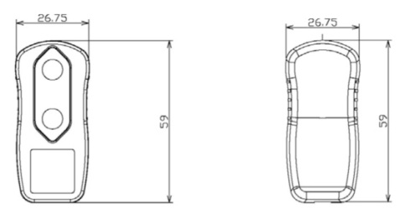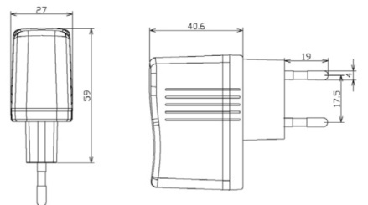 EU fixed adapter
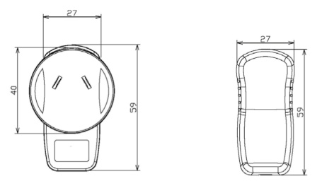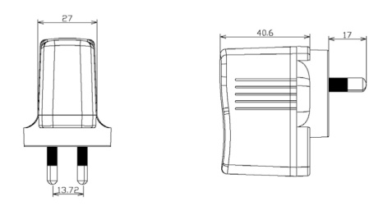AS fixed adapter
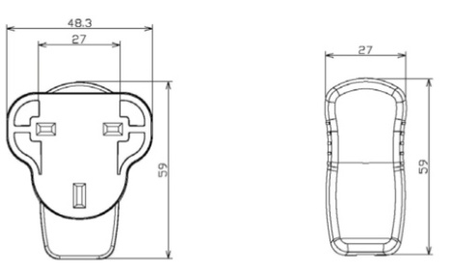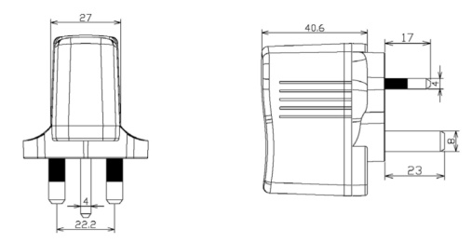UK fixed adapter
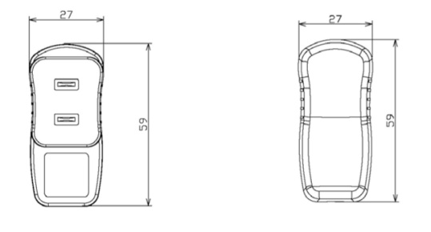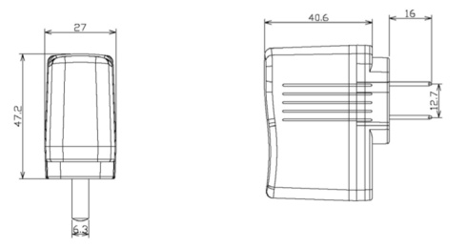China fixed adapter
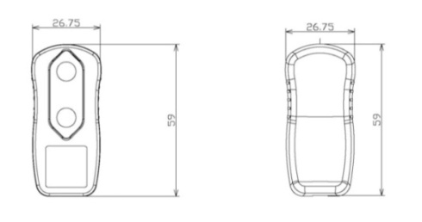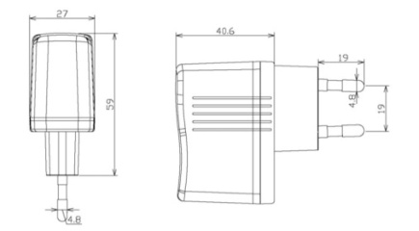Korean Fixed adapter
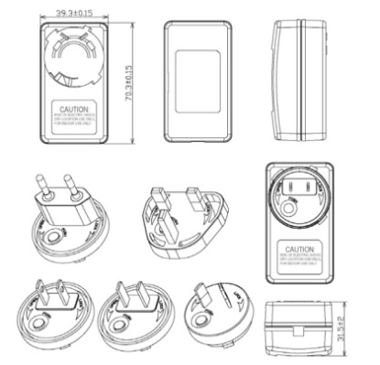 Interchangeable plug adapter

