www.astekglobe.com
ATP200 Open Frame Switching Power Supply
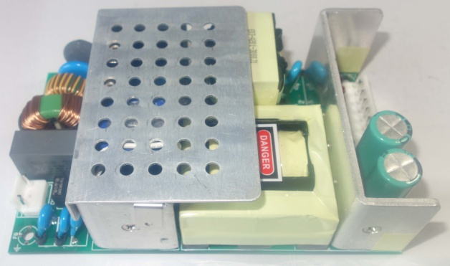
Feature
*Small Size: 3" * 5" footprint design
*Application: Industrial, Printer, Network System, Telecommunication and Storage System.
*Output Power up to 200W.48V-56V suitable
Input
Input Voltage: 90-264VAC
Frequency: 50/60Hz
Input current: @115VAC 4Arms;@230VAC 2Arms
Inrush Current: Cold Start @115VAC< 60A p-p; @230VAC< 100A p-p
Output
Part No Rated O/P(current max.) Forced Air
ATP200-S12 12V/13A/156W 204W
ATP200-S24 24V/7.5A/180W 216W
ATP200-S48 48V/3.8A/182.4W 240W
ATP200-S56 56V/3.57A/200W 250W
General Specification
Line Regulation: +/- 1%
Load Regulation: +/- 5%
Ripple Noise(mV p-p): 200 @12V, 300 @24V, 400 @48V, 500@56V
Efficiency: >83%, >85% for 56V
Turn-On Time (full load @115VAC): 3sec
Hold-up Time (full load @115VAC): 12ms
Safety Ground Leakage Current (Class I @230VAC 50Hz) <3.5mA
Over Voltage Protection: Latch Off(110~170%)
Over Load Protection: Hiccup/Auto Recovery (110%~200%)
Short Circuit Protection: Hiccup/Auto Recovery
Operating Temperature: 0-50 degree C
Storage Temperature: -40~85 degree C
Storage Humidity: 5% ~ 95% RH
Safety and EMC: UL, cUL, CB, CE
