www.astekglobe.com
ATP150 120W-150W Open Frame Switching Power Supply
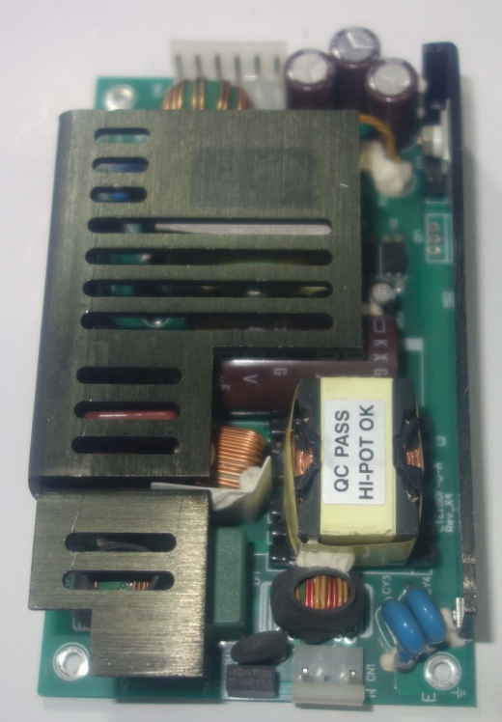
Feature
*Small Size: 3" * 5"* 1" footprint design
*Application: Industrial, Printer, Network System, Telecommunication and Storage System.
*Output Power up to 200W.48V-56V suitable
Input
Input Voltage: 90-264VAC
Frequency: 50/60Hz
Input current:2.5ARMS Max. @115VAC 120W Load; 1.5ARMS max.@230VAC 120W Load
Inrush Current: 80A Typ. Cold Start @25°C, 115VAC
Output
Part No Rated O/P(current max.) Peak Current
ATP150-S12 12V/10A/120W 15A
ATP150-S15 15V/10A/150W 15A
ATP150-S19 19V/7.9A/150W 11.9A
ATP150-S24 24V/6.25A/150W 9.4A
ATP150-S30 30V/5A/150W 7.5A
ATP150-S48 48V/3.2A/153.6W 3.9A
ATP150-S56 56V/2.7A/151.6W 3.3A
General Specification
Line Regulation: +/- 0.5%
Load Regulation: Main Output +/-2%
Ripple Noise(mV p-p): 1% Typ. at full load
Efficiency: >87%
Turn-On Time (full load @115VAC): 3sec
Hold-up Time (full load @115VAC): 16ms
Safety Ground Leakage Current (Class I @230VAC 50Hz) <3.5mA
Over Voltage Protection: 130~160% Latch UP Protection
Over Current Protection: 120-200% Load Fold back
Overshoot/Undershoot: 1% Max @Turn On/Turn Off
Operating Temperature: 0-50 degree C
Storage Temperature: -40~85 degree C
Storage Humidity: 5% ~ 95% RH
Vibration: Random Operating 2.4Grams/max. 3AXES 50~500Hz 10Minutes/AXIS
Shock: Operating Half Sine 20GPK/Max. 3AXES 10ms 6shocks Total
Safety and EMC: UL, cUL, CB, CE
Mechanical Drawing:
