www.astekglobe.com
ATP120-S 100-120W Single Output Open Frame
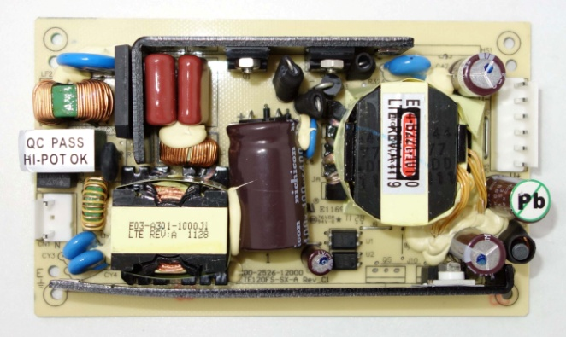
Feature
*Small Size: 3" * 5"* 0.9" footprint design
*Compact size
*High Efficiency
Input
Input Voltage: 100-240VAC
Frequency: 50/60Hz
Input Current: 2.0ARMS. Max @115VAC 120W Load, 1.0ARMS. Max @230VAC 120W Load
Inrush Surge Current: 80A Typical, Cold Start @25 degree C, 115VAC
Power Factor: 0.95~0.99 typical @115VAC/230VAC full load
Output
Output Wattage: 120Watt Max (Convection Rating)
Line regulation: +/- 0.5% typical
Load regulation: main output +/- 2%
Ripple Noise: 1% p-p typical at full load
Efficiency: >87%
Over Current Protection: Typically 120~200% Current Fold Back
Over Voltage Protection: 130~160% Latch Up Protection
Overshoot/UnderShoot: 1% Max @ Turn On/Turn Off
Part No Rated O/P(current max.)
ATP120-S12 12V/8.4A/100W
ATP120-S15 15V/8A/120W
ATP120-S19 19V/6.32A/114W
ATP120-S24 24V/5A/120W
ATP120-S30 30V/4A/120W \
ATP120-S36 36V/3.3A/120W
ATP120-S48 48V/2.5A/120W
Operating Temperature: 0 ~50 degree C Ambient, Derated output 2.5% per degree C from 50 degree C to 70 degree C
Storage Temperature: -40~85 degree C
Humidity: Operating, Non-condensing, 5~95%
Vibration: Random Operating 2.4GRMS/Max. 3 Axes 50~500Hz 10 Minutes/Axis
Shock: Operating Half Sine 20GPK/Max. 3 Axes 10ms 6 shocks Total
Turn-On Time: 3 sec Max at full load @115 VAC
Hold Up time: 16ms Typical at full load @115VAC
EMI, EMC, EMS: FCC & EN55022, EN55024
Designed to meet EN61000-3-3, -4-2, -3,-4,-5,-6,-8,-11
Dimension: 3" * 5" * 0.79" or 2.5" * 5" * 0.79"
Safety: UL, cUL, CE, FCC, TUV-GS
Mechanical Drawing
