www.astekglobe.com
ATP120-D 80W Dual Output Open Frame Switching Power Supply
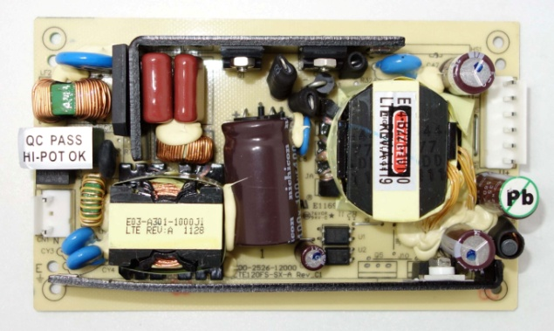
Feature
*Small Size: 3" * 5"* 1.34" footprint design
*Compact size
*High Efficiency
Input
Input Voltage: 90-264VAC
Frequency: 50/60Hz
Input current:1.6ARMS Max. @115VAC 122W Load; 0.8ARMS max.@230VAC 122W Load
Inrush Current: 70A Typ. Cold Start @25°C, 115VAC
Output
Part No Output 1 Output 2
Max (without; with forced air) /Peak current Max (without; with forced air) /Peak current
ATP120-05D12 5V/1.0~6.4A/1.0~10A/11A 12V/0~4.0A/0~6.0A/6.6A
General Specification
Line Regulation: +/- 0.5%
Load Regulation: Main Output +/-2%
Ripple Noise(mV p-p): 1% Typ. at full load
Efficiency: >87%
Turn-On Time (full load @115VAC): 3sec
Hold-up Time (full load @115VAC): 16ms
Safety Ground Leakage Current (Class I @230VAC 50Hz) <3.5mA
Over Voltage Protection: 130~160% Latch UP Protection
Over Current Protection: 120-200% Load Fold back
Overshoot/Undershoot: 1% Max @Turn On/Turn Off
Operating Temperature: 0-50 degree C
Storage Temperature: -40~85 degree C
Storage Humidity: 5% ~ 95% RH
Vibration: Random Operating 2.4Grams/max. 3AXES 50~500Hz 10Minutes/AXIS
Shock: Operating Half Sine 20GPK/Max. 3AXES 10ms 6shocks Total
Safety and EMC: UL, cUL, CB, BSMI, CE
Mechanical Drawing:
