www.astekglobe.com
ATP100 100W Open Frame Switching Power Supply
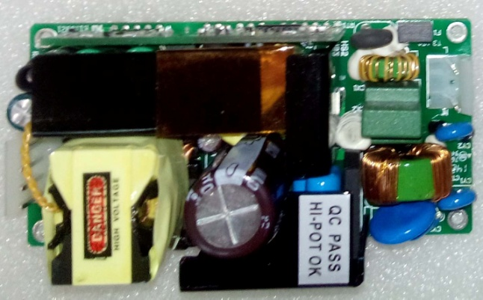
Feature
*Small Size: 2" * 4"* 1.12" footprint design
*Application: Industrial, Printer, Network System, Telecommunication and Storage System.
*Output Power up to 100W.48V-56V suitable
Input
Input Voltage: 90-264VAC
Frequency: 50/60Hz
Input current:1.5ARMS Max. @115VAC 100W Load; 0.7ARMS max.@230VAC 100W Load
Inrush Current: 40A Typ. Cold Start @25°C, 115VAC
Efficiency: >85%
Output
Part No Rated O/P(current max.)
ATP100-S12 12V/8.33A/100W
ATP100-S15 15V/6.66A/100W
ATP100-S19 19V/5.26A/100W
ATP100-S24 24V/4.16A/100W
ATP100-S36 36V/2.8A/100W
ATP100-S48 48V/2.08A/100W
ATP100-S56 56V/1.79A/100W
Line Regulation: +/- 1%
Load Regulation: Main Output +/-5%
Ripple Noise(mV p-p): 1% Typ. at full load, 200mVp-p for 12V/15V/19V
Turn-On Time (full load @115VAC): 3sec
Hold-up Time (full load @115VAC): 16ms
Safety Ground Leakage Current (Class I @230VAC 50Hz) <3.5mA
Over Voltage Protection: 145+/-25% Latch off Protection
Over Current Protection: 110-200% Auto Recovery /Hiccup
Short Circuit Protection: Auto Recovery /Hiccup
Operating Temperature: 0-50 degree C
Storage Temperature: -40~85 degree C
Storage Humidity: 5% ~ 95% RH
Safety and EMC: UL, cUL, CB, CE

Mechanical Drawing:
