www.astekglobe.com
ATP060 26.4W-65W Open Frame Switching Power Supply
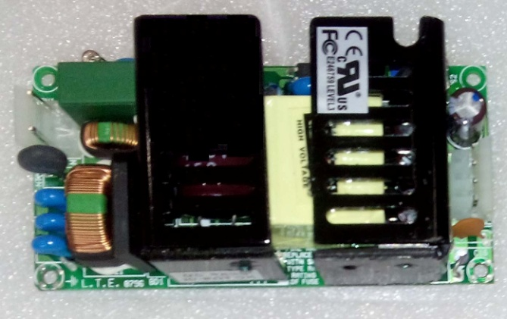
Feature
*Small Size: 2" * 4"* 1.02" footprint design
*Application: Industrial, Printer, Network System, Telecommunication and Storage System.
*Output Power up to 100W.48V-56V suitable
Input
Input Voltage: 90-264VAC
Frequency: 50/60Hz
Input current:1.2ARMS Max. @115VAC; 0.8ARMS max.@230VAC
Inrush Current: <40A p-p Cold Start @25°C, 115VAC, <80A p-p Cold Start @25°C, 230VAC
Output
Part No Rated O/P(current max.) Ripple & Noise(mV p-p) Efficiency (%)
ATP060-S3.3 3.3V/8A/26.4W 66 >75
ATP060-S05 5V/8A/40W 75 >78
ATP060-S09 9V/6.67A/60W 90 >78
ATP060-S12 12V/5A/60W 120 >80
ATP060-S15 15V/4A/60W 150 >81
ATP060-S24 24V/2.7A/60W 240 >84
ATP060-S30 30V/2.17A/65W 300 >84
ATP060-S36 36V/1.8A/65W 360 >84
ATP060-S48 48V/1.36A/65W 240 >84
General Specification
Line Regulation: +/- 0.5%
Load Regulation: Main Output +/-3%
Turn-On Time (full load @115VAC): 2sec
Hold-up Time (full load @115VAC): 16ms
Safety Ground Leakage Current (Class I @230VAC 50Hz) <3.5mA
Over Voltage Protection: 140+/-20% Latch off Protection
Over Current Protection: 110-200% Auto Recovery /Hiccup
Short Circuit Protection: Auto Recovery /Hiccup
Operating Temperature: 0-50 degree C
Storage Temperature: -40~85 degree C
Storage Humidity: 5% ~ 95% RH
Safety and EMC: UL, cUL, CB, CE
