www.astekglobe.com
ATP045 19.8W-50W Open Frame Switching Power Supply
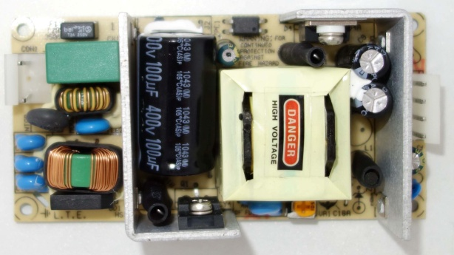
Feature
*Small Size: 2" * 4"* 1.02" footprint design
*Application: Industrial, Printer, Network System, Telecommunication and Storage System.
*Output Power up to 100W.48V-56V suitable
Input
Input Voltage: 90-264VAC
Frequency: 50/60Hz
Input current:1.0ARMS Max. @115VAC; 0.7ARMS max.@230VAC
Inrush Current: <40A p-p Cold Start @25°C, 115VAC, <65A p-p Cold Start @25°C, 230VAC
Output
Part No Rated O/P(current max.) Ripple & Noise(mV p-p) Efficiency (%)
ATP045-S3.3 3.3V/6A/19.8W 66 >69
ATP045-S05 5V/6A/30W 75 >75
ATP045-S09 9V/4.2A/37.8W 90 >78
ATP045-S12 12V/4.2A/50W 120 >80
ATP045-S15 15V/3A/45W 150 >81
ATP045-S24 24V/2.1A/50W 240 >81
ATP045-S30 30V/1.6A/48W 300 >83
ATP045-S36 36V/1.35A/48.6W 360 >83
ATP045-S48 48V/1.05A/50W 480 >84
ATP045-S56 56V/0.8A/45W 560 >84
General Specification
Line Regulation: +/- 0.5%
Load Regulation: Main Output +/-3%
Turn-On Time (full load @115VAC): 2sec
Hold-up Time (full load @115VAC): 16ms
Safety Ground Leakage Current (Class I @230VAC 50Hz) <3.5mA
Over Voltage Protection: 145+/-25% Latch off Protection
Over Current Protection: 110-200% Auto Recovery /Hiccup
Short Circuit Protection: Auto Recovery /Hiccup
Operating Temperature: 0-50 degree C
Storage Temperature: -40~85 degree C
Storage Humidity: 5% ~ 95% RH
Safety and EMC: UL, cUL, CB, CE
Mechanical Drawing:
