www.astekglobe.com
ATA120 SERIES 100W/120W DOE VI Adapter
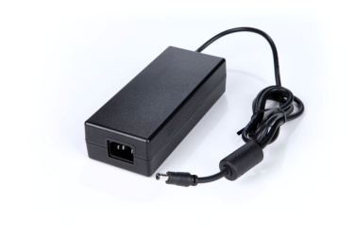
Features
*Universal AC Input Range
*Protections: Short Circuit/Overload/ Overvoltage
*Efficiency: Level VI and V (optional)
*DOE VI/ErP
*Application: IT/Industrial, Telecommunication, Network System, DVR(Digital Video Recorder) etc.
Input
Voltage: 90~264VAC
Frequency: 50~60Hz
Output
Part No Rated O/P
ATA120-S12-z 12V/8.33A
ATA120-S15-z 15V/8A
ATA120-S19-z 19V/6.32A
ATA120-S24-z 24V/5A
ATA120-S30-z 30V/4A
ATA120-S48-z 48V/2.5A
z: 14=C14, 06=C6, 08=C8
Mechanical Drawing C14/C8/C6 inlet, Size: 157*67*40mm
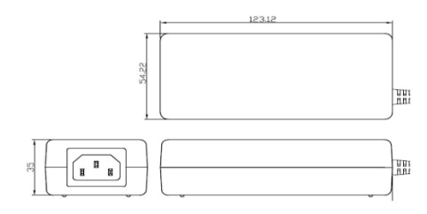
General Specification
Load Regulation: +/-5% Max.
Efficiency Level VI
Over Load Protection/Short Circuit Protection: Hiccup/Auto Recovery
Over Voltage Protection: Latch Off
Operating Temperature: 0~40degree C
Storage Temperature: -40~85degree C
Storage Humidity: 5~95% RH
Safety approvals: DOE VI, UL, cUL,TUV-GS, CB, BSMI
EMC: CE, VCCI, LVD

