www.astekglobe.com
ATA090 SERIES 90W DOE VI Adapter
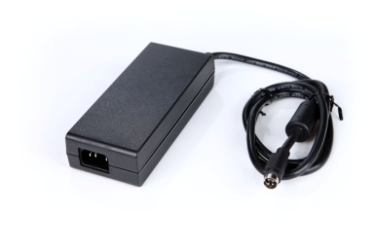
Features
*Universal AC Input Range
*Protections: Short Circuit/Overload/ Overvoltage
*Efficiency: Level VI and V (optional)
*DOE VI/ErP
*Application: IT/Industrial, Telecommunication, Network System, DVR(Digital Video Recorder) etc.
Input
Voltage: 90~264VAC
Frequency: 50~60Hz
Efficiency Level VI
Output
Part No Rated O/P
ATA090-S12-z 12V/7.5A
ATA090-S15-z 15V/6A
ATA090-S19-z 19V/4.74A
ATA090-S24-z 24V/3.75A
ATA090-S30-z 30V/3A
ATA090-S48-z 48V/1.875A
ATA090-S56-z 56V/1.607A
z: 14=C14, 06=C6, 08=C8
Mechanical Drawing C14/C8/C6 inlet, Size: 148*59*32mm

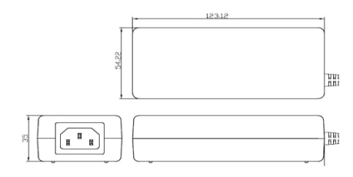
Load Regulation: +/-5% Max.
Operating Temperature: 0~40degree C
Over Load Protection/Short Circuit Protection: Hiccup/Auto Recovery
Over Voltage Protection: Latch Off
Storage Temperature: -40~85degree C
Storage Humidity: 5~95% RH
Safety approvals: DOE VI, UL, cUL,TUV-GS, CB, BSMI
EMC: CE, VCCI, LVD

