www.astekglobe.com
ATA065 SERIES 60W DOE VI Adapter
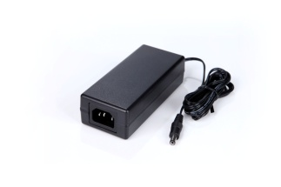
Features
*Universal AC Input Range
*Protections: Short Circuit/Overload/ Overvoltage
*DOE VI/ErP
*Plastic case
*1 year warranty
Application: IT/Industrial, Telecommunication, Network System, DVR(Digital Video Recorder) etc.
Input
Voltage: 90~264VAC
Frequency: 50~60Hz
Input current: 2ARMS @115VAC, 1ARMS@230VAC
Efficiency Level VI
Output
Part No Rated O/P Ripple & Noise(mVp-p)
ATA065-S12-z 12V/5A 200
ATA065-S15-z 15V/4A 200
ATA065-S19-z 19V/3.42A 200
ATA065-S24-z 24V/2.7A 240
ATA065-S48-z 48V/1.35A 480
ATA065-S56-z 56V/1.16A 560
z: 14=C14, 06=C6, 08=C8
Mechanical Drawing C14/C8/C6 inlet, Size: 123.12*54.22*35mm

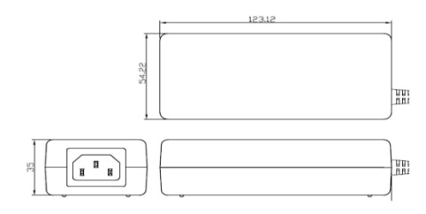
Load Regulation: +/-5% Max.
Line Regulation: +/- 0.5% Max.
Over Load Protection/Short Circuit Protection: Hiccup/Auto Recovery
Over Voltage Protection: Latch Off
Operating Temperature: 0~40degree C
Storage Temperature: -40~85degree C
Storage Humidity: 5~95% RH
Safety approvals: DOE VI, UL, cUL,TUV-GS, CB, BSMI
EMC: CE, VCCI, LVD

